Q 1.

#include <iostream>

using namespace std;

class A

{

public :

int a = 10;

};

class B : public A {

public:

int b = 20;

void display() {

std::cout<< a+b<<std::endl;

}

};

class C : public A {

public:

int c = 44;

void display(){

std::cout<<a+c<<std::endl;

}

};

class D : public A {

public:

int d = 15;

void display(){

std::cout<<a+d<<std::endl;

}

};

int main(){

D d1;

C c1;

B b1;

b1.display();

c1.display();

d1.display();

}

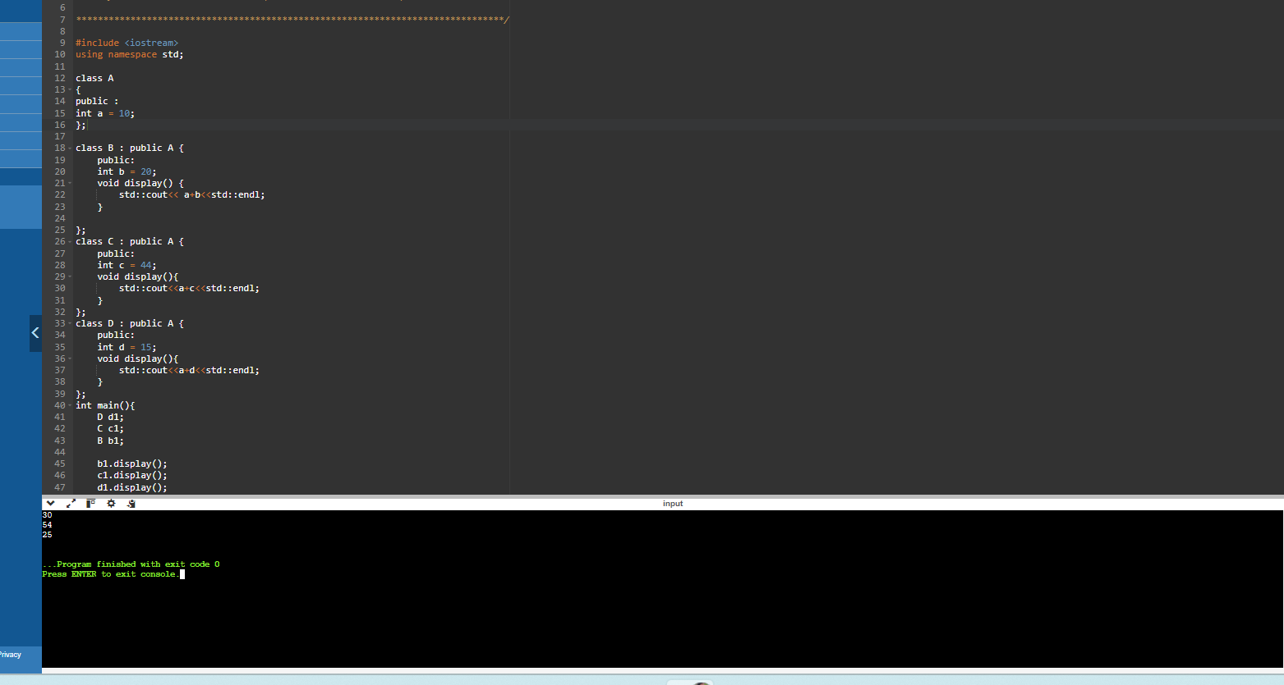

Q 2. #include <iostream>

using namespace std;

class A

{

protected:

int a;

public:

void get_a()

{

cin >> a;

}

};

class B

{

protected:

int b;

public:

void get_b()

{

cin >> b;

}

};

class C

{

protected:

int c;

public:

void get_c()

{

cin >> c;

}

};

class D : public A, public B, public C

{

public:

void mul()

{

get_a();

get_b();

get_c();

cout << "Multiplication of a, b, c is : " << a * b * c << endl;

}

};

int main()

{

D d;

d.get_a();

d.get_b();

d.get_c();

d.mul();

return 0;

}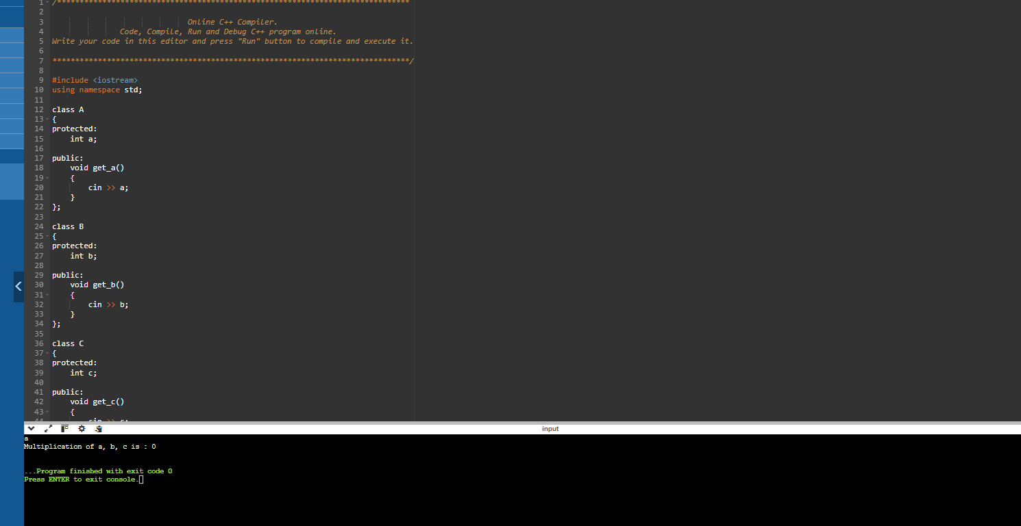

Q 3.

#include <iostream>

using namespace std;

class Animal {

public:

void eat(){

cout<<"Eating...."<<endl;

}

};

class Dog:public Animal {

public:

void bark(){

cout<<"Barking....."<<endl;

}

};

class BabyDog: public Dog {

public:

void weep() {

cout<<"weeping....";

}

};

int main(void){

BabyDog d1;

d1.eat();

d1.bark();

d1.weep();

return 0;

}

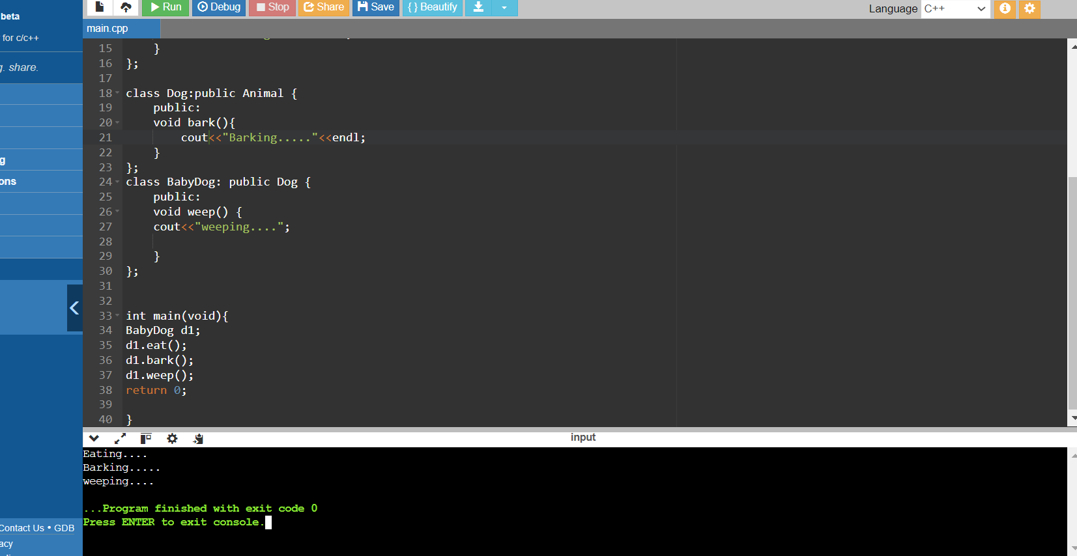

Q 4.

#include <iostream>

using namespace std;

class Account {

public:

float salary = 6000;

};

class programmer: public Account {

public:

float bonus= 5000;

};

int main(void){

programmer p1;

cout<<"Salary: "<<p1.salary<<endl;

cout<<"Bonus: "<<p1.bonus<<endl;

return 0;

}

